**Q1: Program to Input Two Numbers and Print the Sum.**

**Code:**

dosseg

.model small

.stack 100h

.data

.msg1 db 'Start$'

.msg2 db 'End$'

.code

main proc

mov ah,1

int 21h

mov bl,al

mov ah,1

int 21h

Add bl,al

Sub bl,48

mov dl,bl

mov ah,2

int 21h

mov ah,4ch

int 21h

main endp

end main

**Output:**

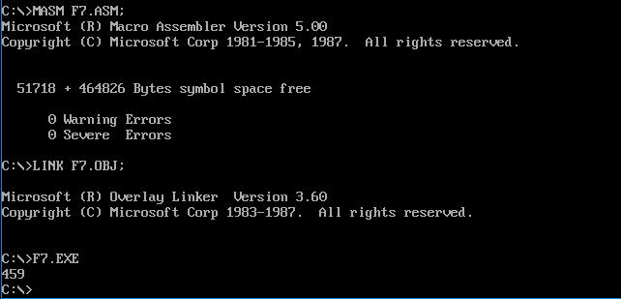

**Q2. Program to Print Two Strings on Two Different Lines.**

**Code:**

dosseg

.model small

.stack 100h

.data

.msg1 db 'ASALAM U ALIKUM$'

.msg2 db 'HAVE A NICE DAY$'

.code

MAIN PROC

mov ax,@data

mov ds,ax

mov dx,offset msg1

mov ah,9

int 21h

mov dx,10

mov ah,2

int 21h

mov dx,13

mov ah,2

int 21h

mov dx,offset msg2

mov ah,9

int 21h

mov ah,4ch

int 21h

main endp

end main

**Output:**

